**Keyestudio V4.0 Development Board**

You need to know that keyestudio V4.0 development board is the core of this 4WD BT Multi-purpose Car V2.0.

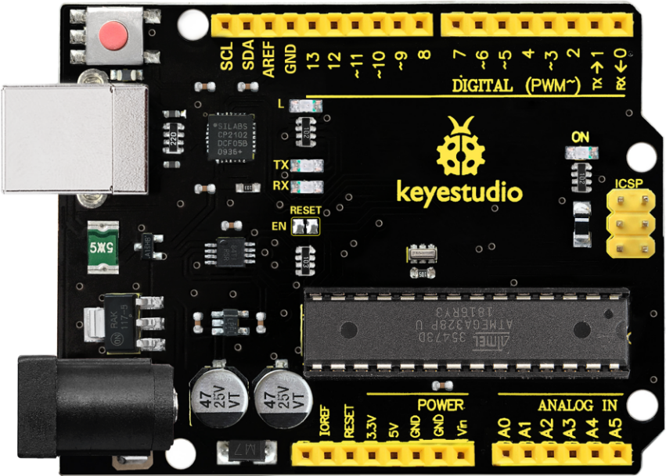

Keyestudio V4.0 development board is an Arduino Uno -compatible board, which is based on ATmega328P MCU, and with a CP2102 chip as a UART-to-USB converter.

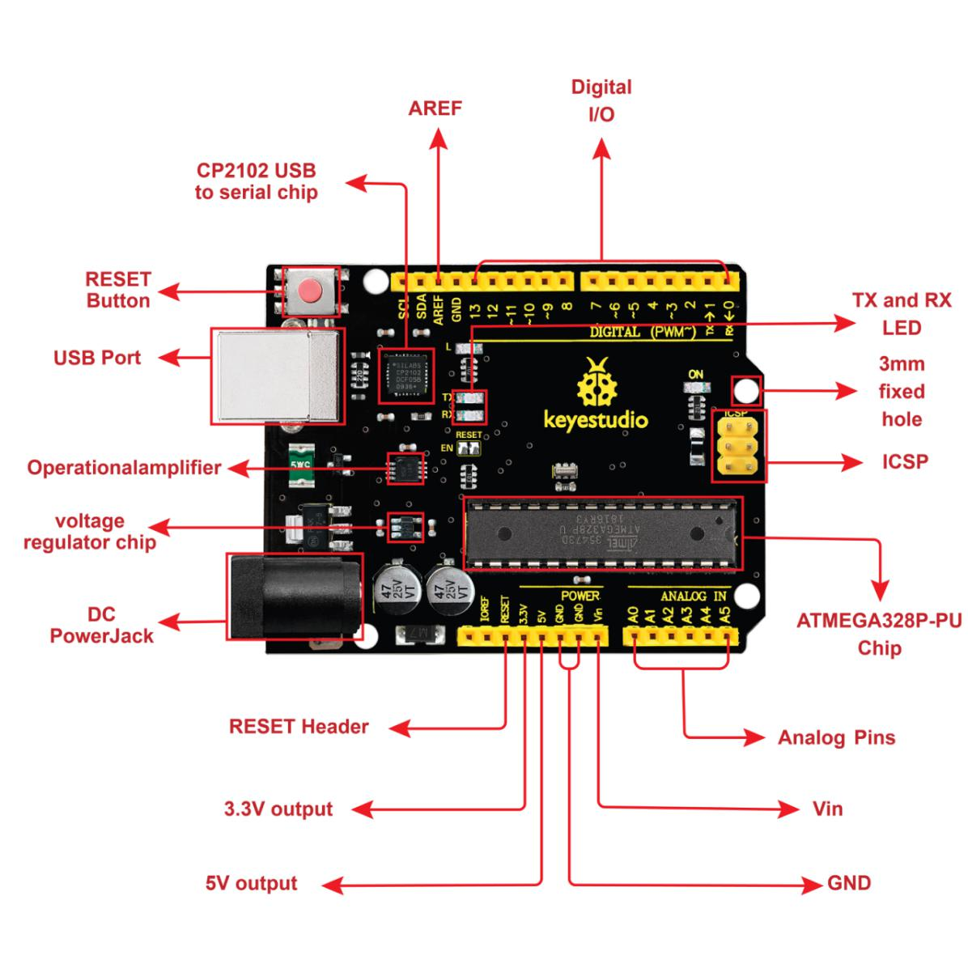

It has 14 digital input/output pins (of which 6 can be used as PWM outputs), 6 analog inputs, a 16 MHz quartz crystal, a USB connection, a power jack, 2 ICSP headers and a reset button.

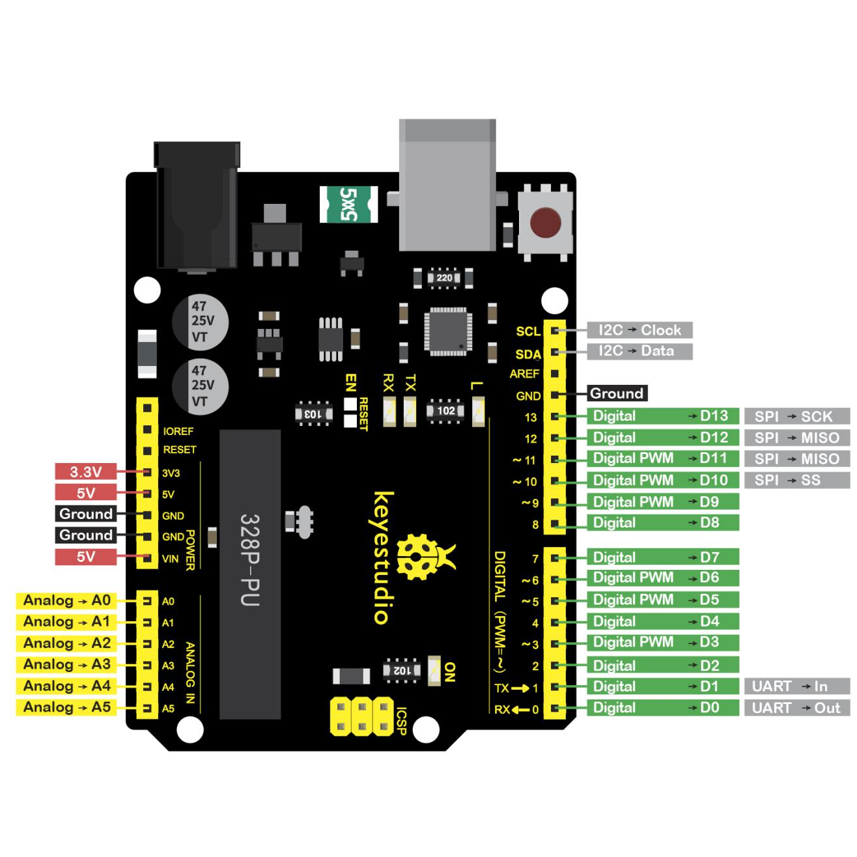

It contains everything needed to support the microcontroller: simply connect it to a computer with a USB cable or power it via an external DC power jack (DC 7-12V) or via female headers Vin/ GND(DC 7-12V) to get started.

|  |  |
| --- | --- |
| Microcontroller | ATmega328P-PU |
| Operating Voltage | 5V |
| Input Voltage (recommended) | DC 7-12V |
| Digital I/O Pins | 14 (D0-D13)  (of which 6 provide PWM output) |
| PWM Digital I/O Pins | 6 (D3, D5, D6, D9, D10, D11) |
| Analog Input Pins | 6 (A0-A5) |
| DC Current per I/O Pin | 20 mA |
| DC Current for 3.3V Pin | 50 mA |
| Flash Memory | 32 KB (ATmega328P-PU) of which 0.5 KB used by bootloader |
| SRAM | 2 KB (ATmega328P-PU) |
| EEPROM | 1 KB (ATmega328P-PU) |
| Clock Speed | 16 MHz |
| Onboard LED | D13 |